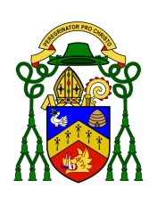
Diocesan Curia, 24-28 Lawside Road, DD3 6XY e mail bishop@dunkelddiocese.org.uk
FOR INFORMATION ONLY
TO ALL PRIESTS, DEACONS, RELIGIOUS AND PEOPLE OF
THE DIOCESE OF DUNKELD
28th December 2022 Feast of the Holy Innocents

Dear brothers and sisters,
Very recently I received from Archbishop Gugerotti, the Papal Nuncio, a letter from Pope Francis stating that he had accepted my resignation as Bishop of Dunkeld under Canon 401, para 2, on grounds of failing health. In his own covering letter, the Nuncio states: ‘The Holy Father assures you of his gratitude for your faithful ministry and sends warm greetings and prayerful good wishes for your health and future endeavours’.
I first wrote to the Holy Father offering my resignation and request for retirement in March 2021, and in November 2021 His Excellency the Nuncio told me that the Holy Father had accepted my resignation ‘Nunc pro Tunc’, which meant that it was accepted now, but that it would only be announced once a Bishop successor was appointed. I know that during this past year (2022) rumours have circulated that I was about to retire, and that the process for the selection and appointment by the Holy Father of a new Bishop had already begun. Unfortunately, though the process is well under way, the nomination of a new Bishop for Dunkeld is not yet completed. However, the Holy Father has now accepted my resignation on grounds of ill health (c. 401, para2; 416), and it was made public today, as you may know by now, at 12:00 o'clock in Roman time, (which is 11 am in the UK). As from this date and time, the Diocese of Dunkeld is now vacant (sede vacante), and I am known now as the emeritus bishop of Dunkeld.
Since the Holy See is not yet at the point of being able to nominate and appoint a new diocesan Bishop, all vicarious Offices in the Diocese cease - including the Episcopal Vicars and Vicars General, but with the exception of the Chancellor - and lose authority. The task now falls to the College of Consultors, a sub-set of the Council of Priests, to elect a Diocesan Administrator from among the priests of the diocese who are eligible ‘from those priests who are above 35 years of age and are upright and have strong faith and good prudential judgement‘. This election ought to be conducted within eight days of the notification that the See of Dunkeld is vacant. The Diocesan Administrator is to ensure the smooth overall conduct of diocesan affairs, though during a vacant See there is to be nothing innovated which might affect the patrimony of the diocese (‘sede vacante, nihil innovetur’). The duties of the Diocesan Administrator are outlined in the Code of Canon Law (1983). Essentially, the Diocesan Administrator is to keep the diocese ticking over until a new Bishop is appointed. The code of Canon law itself outlines how the Diocesan Administrator is to proceed - cautiously and carefully - to keep the business of the diocese on an even keel. He is not to innovate or conduct major business. Accordingly, within the next eight days the College of Consultors of the diocese must gather together and, according to the canons must validly elect an Administrator, whose name must be submitted via the Nuncio to the Holy See. As I have said, all other vicarious offices, except the Chancellor will cease, though doubtless the Administrator will call on those priests involved to carry on their functions as usual to help him.
Since I came to the diocese in 2013, the priests, people, religious and deacons have been very good to me, and I have tried to serve them as best I can. I am now almost 72 years of age and although three years short of the normal retiring age I am, as you might expect, sad to have come to the conclusion that I no longer have the strength to carry on effectively shepherding the diocese. However, I am happy to say that the diocese is in relatively good shape, and I have every confidence that a good, younger, and fitter priest will soon be selected by the pope to carry on work of pastoring and feeding the People of God by means of the Word of God and the Sacraments.
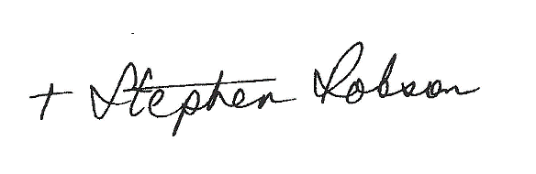
With every blessing
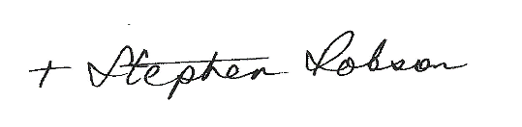

+ Stephen Robson, Bishop emeritus of Dunkeld

